LISY35
LInux for SYstem35
( Bally AS-2518-17 & AS-2518-35 )

Hardware Version 1.5
Board Assembly

ralf@lisy.dev
19.11.2019 Version 1.1
Inhaltsverzeichnis
Important remark 3
1. Bill of Material 4
1.1. Basic function 4
1.2. WLAN Option 5
1.3. Sound Option 1 5
1.4. Sound Option 2 5
2. Step by Step 6
2.1. Step1: X1, diodes, resistors 6
2.2. Step 2. LEDs, IC-sockets, resistors arrays and push buttons 7
2.3. Step 3, Elko C1 & Switches, Header and Socket for Raspberry PI 8
2.4. Step 4, Placement of all IC and the Raspberry PI 9
2.5. Step 5, Sound Option 1 (optional) 9

Important remark

By using LISY35 it is possible to damage your pinball machine. As this is a private project with NO commercial interest the author accepts no liability for any damage that may arise by using LISY35!

Note:
All pictures are from Hardware Version 1.3! Up to version 1.3 I did use LEDs with integrated resistors. With version 1.5 I do use standard LEDs with separate resistors (220 Ohm). All other components are identical.

Bill of Material
All components are included in the in the ‚Reichelt Warenkorb‘ ( see link at www.lisy.dev ).

Basic function
The following components (pluse the PCB) are needed for a working LISY35 board
Quantity | Label | Function | Label Reichelt
1 | IC1 | Displays | PIC18F45K22-I/P
1 | IC2 | Solenoids & Lamps | PIC18F45K22-I/P
1 | IC3 | Switches | PIC18F45K22-I/P
1 | X1 | I2C Bus Repeater | PCA 9517 D
1 | IC4 | Adaption 3,3V PI | 74HC 4050
1 | IC5 | Zero cross detection | 74HC 4049
1 | C1 | 5V Capacitor 100µF | AX 100/16
8 | C2-C9 | Capacitor 100nF | Z5U-5 100N
23 | C11-C23, C25-C34 | Capacitor 470pF
1 | C24 | Capacitor 3,3nF
1 | C35 | Capacitor 820pF
51 | R1-R27, R51-R63,  R43, R65-R74 | Resistor 1,2K
7 | R28-R31, R36, R78-R79 | Resistor 470
4 | R32-R35 | Resistor 330
2 | R37,R45 | Resistor 2,2K
1 | R46 | Resistor 150K
1 | R47 | Resistor 1,5M
3 | R75-R77 | Resistor 10K
3 | R39,R41,R44 | Resistor Array 3,3K | SIL 9-8 3,3K
2 | R38, R40 | Resistor Array 3,3K | SIL 5-4 3,3K
1 | R42 | Resistor Array 56K | SIL 9-8 56K
1 | R64 | Resistor 110
1 | R80 | Resistor Array 220 | SIL 5-4 220
5 | R81-R85 | Resistor 220
3 | D1, D6, D7 | Standard LED 3mm green
2 | D5, D9 | Standard LED 3mm yellow
4 | D2, D3, D4, D8 | Standard LED 3mm red
37 | D10-D46 | 1N4148
6 | S1,S2, S4-S7 | Dip Sw 8 | NT 08
2 | S3,S33 | pushbuttonShutdown Debug Mode & Bally Reset | TASTER 3301
5 |  | Jumper Debug Optionen | JUMPER 2,54 SW
1 | K2 | Seriell connection (3V!) | PSS 254/5G
1 | K3,K4,PI | Male header | SL 2X40G 2,54
2 | J1-J4 | Male header | MPE 087-1-050
1 |  | Conn Header female for Raspberry PI | MPE 094-2-040 or 1 x Extra Tall Header
3 |  | IC- Socket IC1,2,3 | GS 40P
2 |  | IC- Socket IC4, IC5 | GS 16P
1 | SD Karte | 8 GB Micro SD | INTENSO MSDHC8G
1 | PiZero | ‚the master‘ ;-) | RASP PI ZERO WH

WLAN Option
If you want to use ‚LISYcontrol‘ (recommended) a (Wireless) LAN connection is needed. This is included in the PI-Zero-W, with the ‘old’ PI-Zero without Wireless LAN you will need a Wireless LAN ‘USB Stick’ and an Adpater.

Sound Option 1
With the sound option you can replace the original soundcard and use your own sounds ( .wav files).
Quantity | Label | Function | Label Reichelt
1 | C10 | Capacitor 220nF | Z5U-5 220N
2 | R48,R49 | Resistor 1K | 1/4W 1,0K
1 | R50 | Potentiometer 10K linear | PT 10-L 10K
1 |  | Male header 1*3 | MPE 087-1-003
1 |  | Male header | SL 2X40G 2,54
1 |  | Jumper int/ext Speaker | JUMPER 2,54 SW
1 | Amp zero | Justboom | (*)JustBoom Amp Zero pHAT

Sound Option 2
With the components of Sound option2, you are able to control the sound volume with the pot in the coin door at the front. New wiring needed!
Quantity | Label | Function | Label Reichelt
1 |  | Potentiometer 6mm 10K | PO6M-LIN 10K
1 |  | Wannenstecker AKL | AKL 169-02
1 | K5 | Anschlussklemme 2pol | AKL 182-02
1 |  | Lautsprecherlitze 0,75 | LAT 275-10
4 |  | Flachsteckhülsen | FSH-R-4,75

Step by Step
This Guide starts with the components with the least height and went from there step by step.
Please watch carefully the orientation of the components marked at the PCB. As I did some ‘optimization’ with the wiring (yes I did this by hand) you cannot expect that all parts have the same orientation. Especially with the resistor Arrays take a second look to be on the save side and watch the right position of ‘PIN1 ‘.

Note: all pictures are form Hardware version 1.2, which is a bit different from HW Version 1.3

Step1: X1, diodes, resistors
We start with the one and only SMD part the ‚I2C Bus Repeater X1.‘
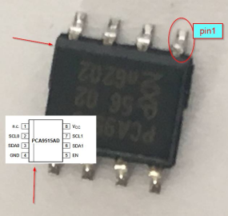
It could be difficult to identify ‘pin1’ of this SMD Chip. Depending on which variant you have it could be marked with a dot, or the side with pins 1..4 are a bit sloped. See picture on the left for details.

If you are unsure that the soldering has contact, check the following connections from X1
Pin 1 ( VCC 3V) -> Pin1 PI Pin 2 (SCL0) -> Pin5 PI
Pin 3 (SDA0) -> Pin 3 PI Pin 4 (GND) -> Pin 6 PI
Pin 5 -> not used Pin 6 (SDA1) -> Pin 3 R40
Pin 7 (SCL1) -> Pin 2 R40 Pin 8 (VCC 5V) -> Pin2 PI
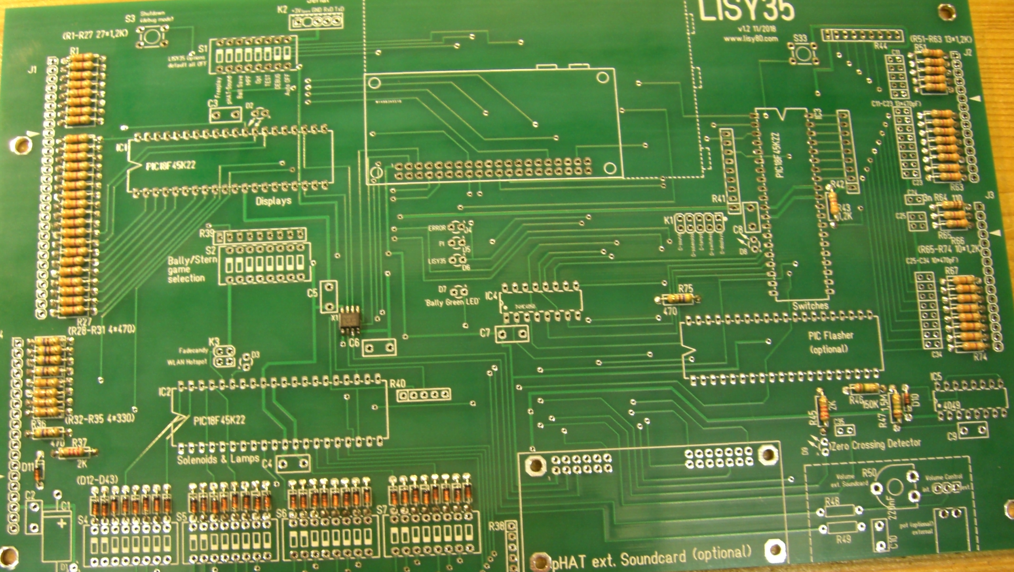
Picture 1: LISY35 after step1 (HW Version 1.2)

Step 2. LEDs, IC-sockets, resistors arrays and push buttons
The position of the anode of LEDs are marked with an ‚A‘ on the PCB. Hint: With new LED you can identify the anode by looking for the longer PIN. Some LEDs also have marked the Cathode with a small dot.
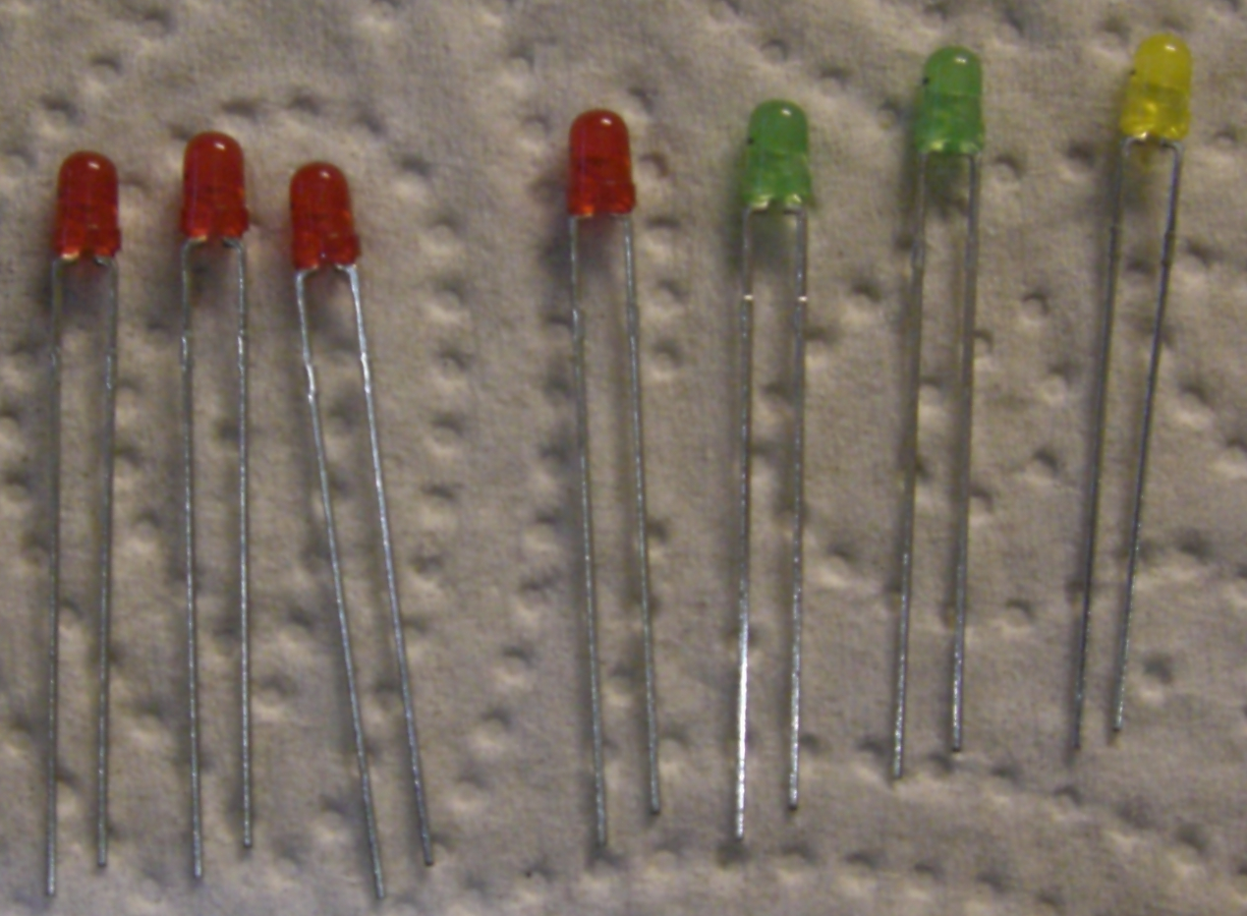
Picture 2: LEDs with the longer PIN (anode) on the left Important: Only use 5V LEDs with integrated resistor!
The resistor arrays (R1 – R4 & R8) are marked with a dot at Pin1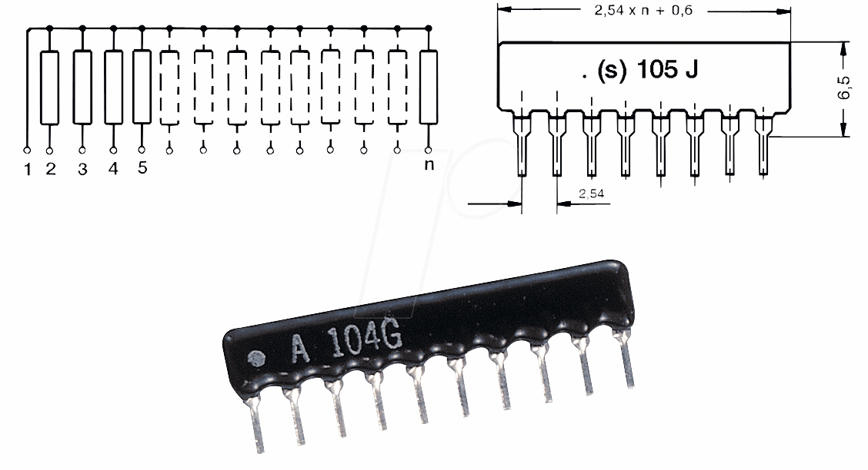
You will find that Pin 1 marked with a small quadrat on the PCB.
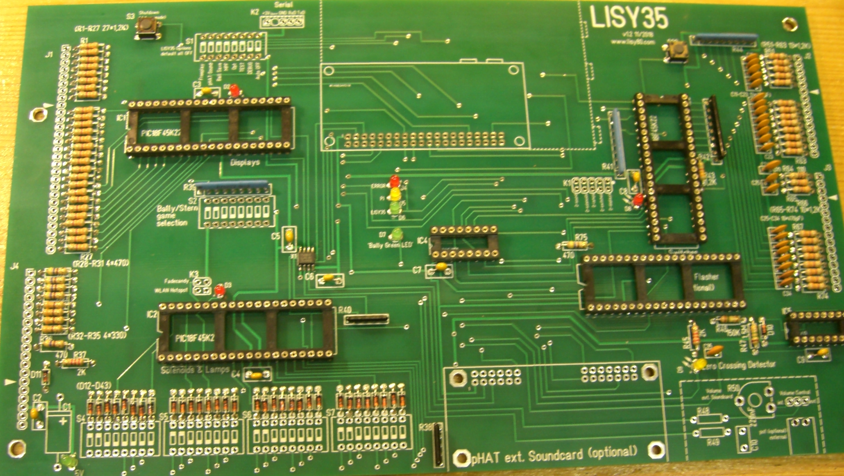
Picture 2: LISY35 after step2 (HW Version 1.2)

Step 3, Elko C1 & Switches, Header and Socket for Raspberry PI
Place the big Elko C1 and the six Dip Switch banks as noted on the board.
For the Headers J1-J4 after soldering you need to remove one pin from each Header, as they are used as ‘Key’ for the connectors. The four pins which needed to be removed are marked with an arrow/triangle on the board. Just cut them with a wire cutter.
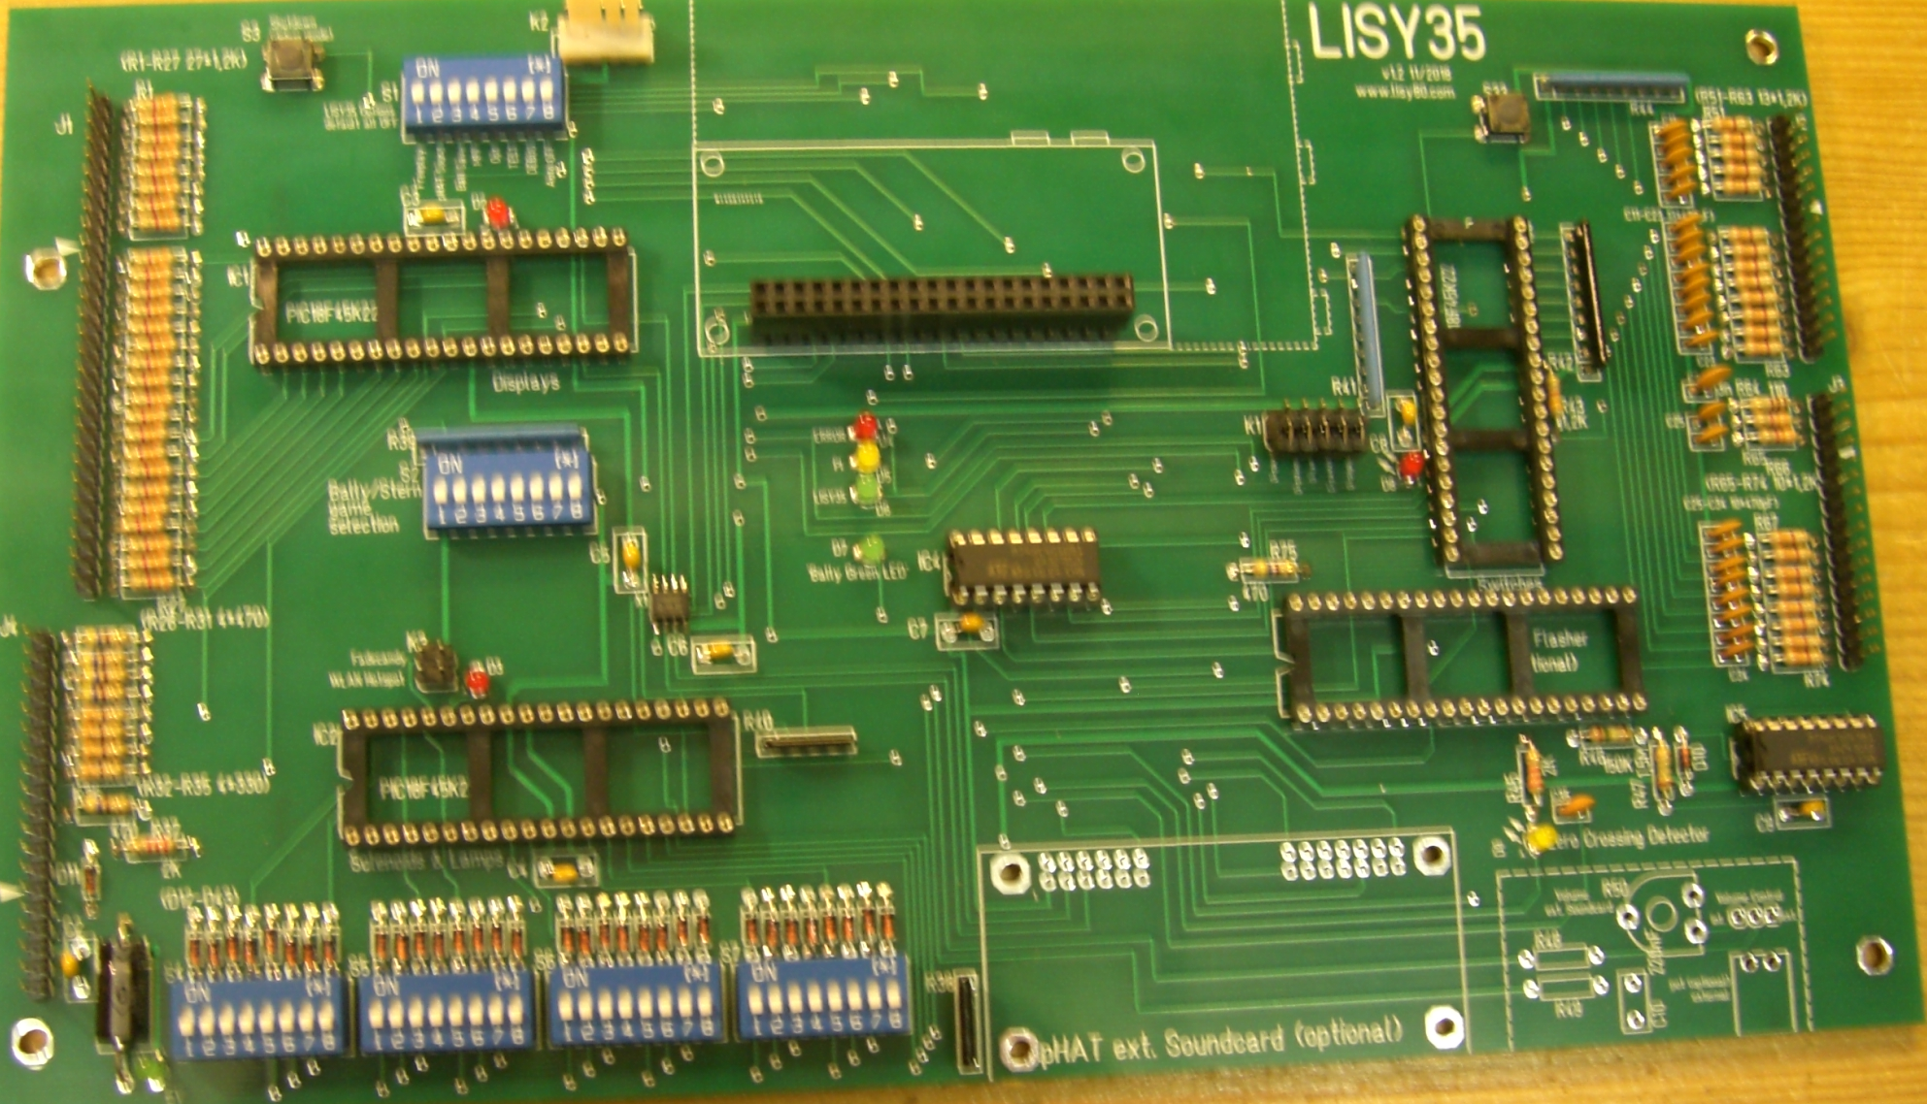
Picture 3: LISY35 after Step 3. (HW Version 1.2)

Step 4, Placement of all IC and the Raspberry PI
After a final check of your soldering work, you can now place all the IC in the sockets. Again look carefully on the orientation of the ICs.
For further instructions on how to place the ‘LISY’ image onto the SD card have a look at user manual.
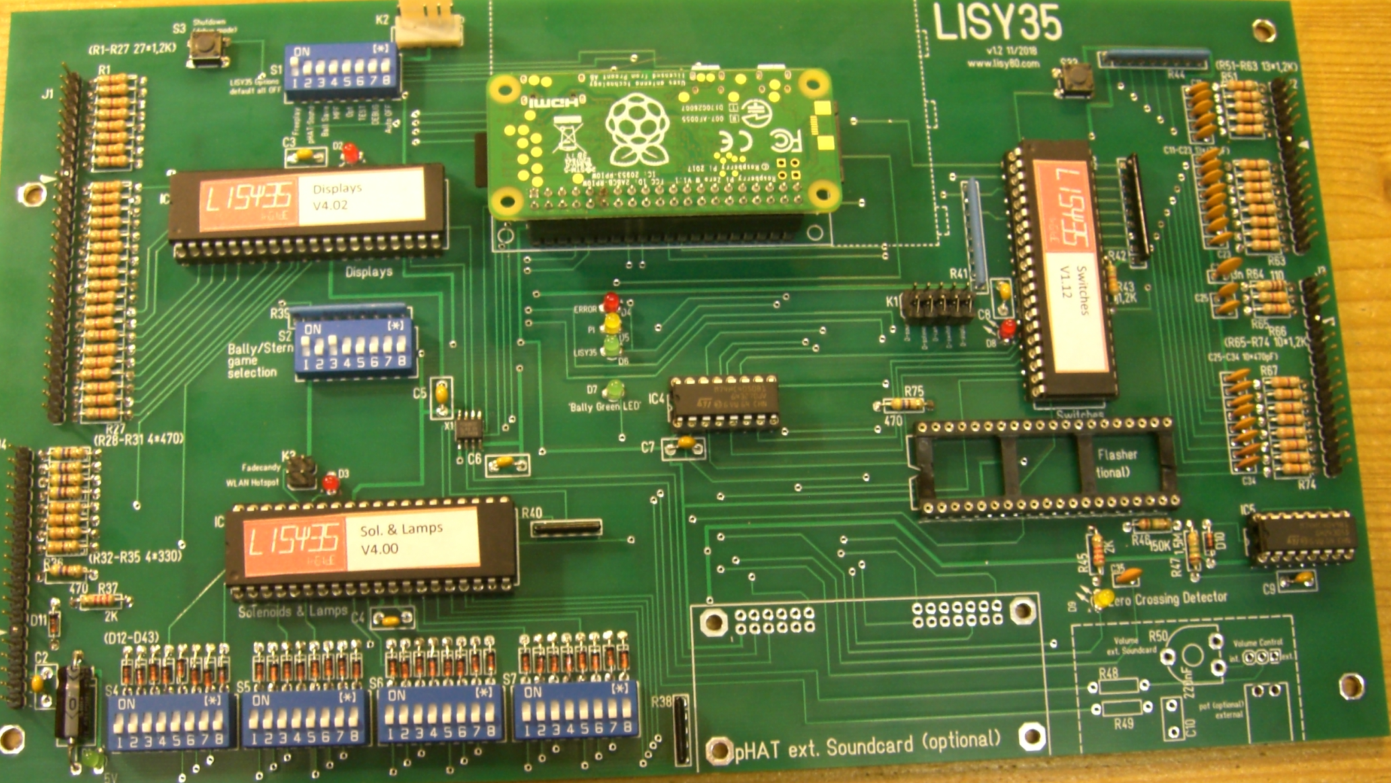
Picture 3: LISY35 after Step 4. ‘Ready to go’(HW Version 1.2)

Step 5, Sound Option 1 (optional)
Place all the components from the sound option 1 list and make sure you place the jumper to the ‘internal’ position.

